**SUNY New Paltz Campus Tree Plan - 2017**

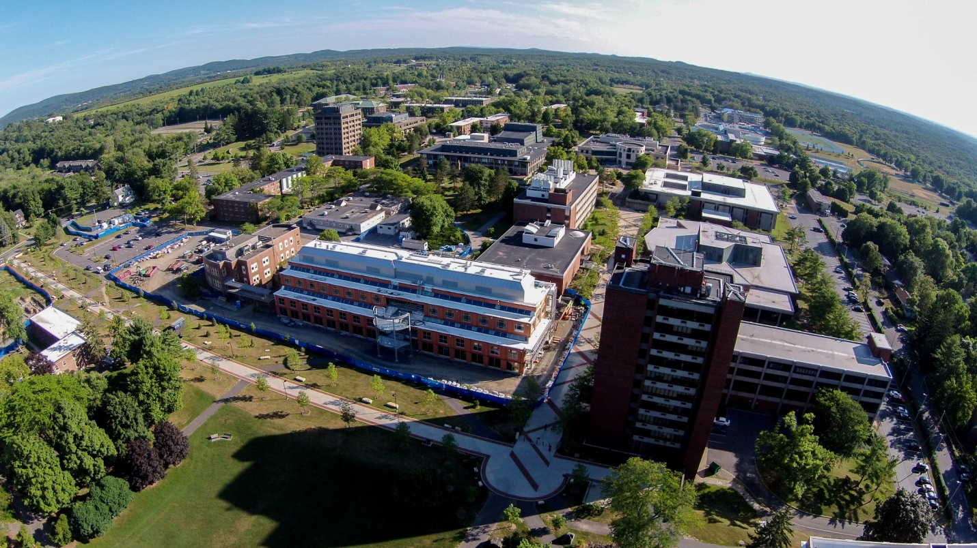

**Table of Contents**

Standard 1 – Campus Tree Advisory Committee ………………………………..3

Standard 2 – Campus Tree Care Plan

1. Purpose…………………………………………………………………….3

2. Responsible department………………………………………………....4

3. Establishment of a Campus Tree Advisory Committee….……………4

4. Campus tree care policies……………………………………………….4-7

5. Protection and preservation policies and procedures………………...7

6. Goals and targets………………………………………………………....8

7. Tree damage assessment………………………………………………..8

8. Prohibited practices……………………………………………………….9

9. Definitions of terminology………………………………………………...9-10

10. Communication strategy…………………………………………………10

Standard 3 – Dedicated Annual Expenditures……………………………………10-11

Standard 4 – Arbor Day Observance……………………………………………...11

Standard 5 – Service Learning Project……………………………………………11

Appendix 1. Announcement of Arbor Day Event…………….…………………..12

Appendix 2. Photo & Description of the Arbor Day Tree Planting ………….….13

Appendix 3. Student Research Paper……………………………………………..14-22

**Standard 1 – Campus Tree Advisory Committee**

The committee is comprised of faculty, staff, students, and community members. Members will serve for a renewable term of two academic years, with the exception of students who will serve for a term of one academic semester or year. Members meet at least once each semester or more often if needed. In 2017, the committee met on June 7and again on October 10.

Committee members include the following:

Eric Keeling Assistant Professor, Biology,

keelinge@newpalz.edu

John Sharp Associate Professor, Geography,

sharpj@newpaltz.edu

Carol Rietsma Associate Professor Emerita, Biology,

rietsmac@newpaltz.edu

Lisa Mitten Sustainability Coordinator, Facilities Department

mittenl@newpaltz.edu

Richard Drosdowich Grounds Supervisor, Facilities Department,

drosdowr@newpaltz.edu

Geralyn Torrone Student Accounts Staff,

torroneg@newpaltz.edu

George Profous Forester, DEC Region 4,

gvprofou@gw.dec.state.ny.us

Dejea Green Student,

[greend6@hawkmail.newpaltz.edu](mailto:greend6@hawkmail.newpaltz.edu)

While the responsibility for campus trees ultimately lies with the Facilities Department, the Campus Tree Advisory Committee will provide guidance for future planting, liaise with Design and Construction in Facilities, educate the College community about the benefits of the campus trees, develop connectivity to the Town and Village of New Paltz, review and revise the campus tree plan, and update the tree inventory with the assistance of interested students on a periodic basis.

**Standard 2 – Campus Tree Care Plan**

**1. Purpose**

The purpose of the plan is to provide a safe, attractive, and sustainable campus tree-scape. The specific objectives are:

* Promote age and species diversity in the campus tree through the use of native species and, if appropriate, some noninvasive/nonnative species;
* Protect and maintain high value campus trees during construction and renovation projects;
* Ensure that campus trees are replaced when there is mortality due to weather, pest infestation, injury, or construction; and
* Encourage the college community to respect and value the campus tree-scape.

**2. Responsible Department**

Responsibility for the Campus Tree Plan rests with the Facilities Department.

**3. Campus Tree Advisory Committee** See Standard 1 above.

**4. Campus Tree Care Policies**

**Tree Selection**

The following native species are recommended for future planting and replacement. In addition, some noninvasive/nonnative species may be planted for educational purposes. For example, Dr. Eric Keeling, ecologist in the Biology Department, would like to have an eastern larch (*Larix laricina*) tree planted on campus for educational purposes. It is an important and physiologically interesting tree species found primarily in the boreal forests of Canada. In addition, it would likely have no negative ecological/environmental effects. Dr. Keeling will be consulted by the Facilities Department concerning plantings on the campus since SUNY New Paltz does not have an arborist on its staff.

The tree recommended for planting is the oak with many species native to the Northeast because it is more disease and insect resistant than other trees. Other trees and shrubs used for planting are part of natural oak communities and grow under similar conditions. The following is a list of trees from the SUNY New Paltz Site and Landscape Master Plan (https://newpaltz.edu/media/construction/pdfs/facilities_master_plan.pdf).

* *Amelanchier* sp Serviceberry/Shadblow
* *Carpinus betulus fastigiata*  European hornbeam
* *Carya ovata* Shagbark hickory
* *Cercis canadensis* Eastern redbud
* *Cladrastis lutea* Yellowwood
* *Cornus* sp Dogwood
* *Fagus grandifolia* Beech
* *Hamamelis virginiana*  Witch hazel
* *Juniperus virginiana*  Eastern red cedar
* *Liquidambar styraciflua* Sweet gum
* *Liriodendron tulipifera* Tulip tree
* *Magnolia virginiana*  Sweet bay
* *Nyssa sylvatica* Sour gum
* *Ostrya virginiana* American hornbeam
* *Pinus strobus* White pine
* *Prunus serotina*  Black cherry
* *Quercus alba*  White oak
* *Quercus prinus* Chestnut oak
* *Quercus rubra* Red oak
* *Quercus velutina*  Black oak
* *Sassafras albidum* Sassafras
* *Taxodium distichum* Bald cypress

Trees to be used on campus are purchased from a reputable farm or nursery for good quality and tagged. They must have a minimum caliper of 3”.

**Planting**

Site preparation.

Trees are planted in the fall months before the ground freezes, or alternatively, after the ground thaws in the spring. No planting will be done during the summer.

The planting hole should be two to three times the diameter of the root ball of a tree and no deeper than the root ball. The trunk flare of a tree should be 1-2 inches above the existing grade.

Preventive setting and backfilling.

To avoid damaging the tree when setting it in the hole, the tree should always be lifted by the root ball. The tree should be straightenedwithin the hole, being sure to view the tree from several directions to confirm the tree is straight. About one third of the hole should be gently packed with soil around the root ball. Once the plant is properly placed, outside ropes, burlap and/or wire basket should be removed from the top one-third of the root ball. The remainder of the hole should be filled with soil, gently packed to remove air pockets that may cause roots to dry out. The root ball must be thoroughly watered and more soil must be added if settling of backfill occurs.

**Mulching**

The tree ring will be covered with 2-4 inches of mulch making sure the trunk is not

covered. There should be a mulch free area of 1-2 inches from the trunk flare. Mulching is done to deter weeds and to provide a guide for mowers and equipment so that newly-planted and young trees along with their roots are protected from vehicles and equipment. Mulching of trees is typically done annually in the spring.

See the diagram below which summarizes proper planting procedures.



**Staking**

Staking of trees at planting will not be done unless the rootball is unstable.

**Watering**

Newly planted trees must receive adequate water weekly during the entire first growing season right up until dormancy in the fall. This is accomplished by placement of an ooze bag or by hand-watering with a mobile tank. Watering is the responsibility of the Facilities Department and the contractor in the case of newly planted trees after construction is completed.

**Memorial Trees**

Individuals and organizations seeking to dedicate a tree in memory or in honor of a member of the College community contact the Development/ Foundation of SUNY New Paltz. A donation of $3,000 is requested to plant and install a memorial tree while a donation of $1500 is requested to dedicate an existing tree. The donation also provides funds for future maintenance of these trees. Tree plaques are placed in the mulching bed.

**Fertilization and pest management**

There is no fertilization or use of chemicals to control pests.

**Pruning**

To encourage the development of a strong, healthy tree, the following guidelines shall

be followed when pruning. Pruning will not be conducted without a clear objective. The order of significance of objectives is as follows: safety, health of tree, aesthetics, and nighttime light dispersion for pedestrian safety.

When removing branches, the pruning cut should not damage the branch bark

ridge and branch collar. Internode (heading) cuts should not be used except in storm response and crown restoration procedures. Branch reduction or thinning should be used to remove dead, diseased, dying, and defective branches. Large branches should be removed using ropes and rigging equipment to minimize the risk of human and tree injury.

**Removal**

Trees will be removed if the tree is dead, severely damaged, compromised as to

be a safety hazard, or is in a construction site. There will be no net loss of trees on the campus at any time. An equal number of trees will be planted elsewhere on the campus any time trees are removed from an area.

**Managing for catastrophic events**

Storm response and recovery are generally accomplished in-house. Additional labor

may be contracted. In a crisis, the first priority is to remove tree debris that blocks

campus roads and walkways, disrupts operations, or poses hazards to the campus

community. Then access to critical buildings (administration, buildings with critical labs,

library, student center, etc.) will be cleared in that order

**5. Protection and preservation policies and procedures**

Protection of trees that remain within a construction site is a high priority and the college

requires contractors to use every reasonable measure to protect the root systems and

canopies of these trees.

**Planning before Construction**

Notification.

During the design phase of construction, Facilities Department staff and the grounds supervisor will walk the proposed work site with the architect of the design project in order to assess trees within the site. Recommendationsfor tree protection, removal, or transplantation will be based on assessment of the site. Trees that will interfere with construction are removed. Desirable trees in a construction site will be transplanted to an acceptable location and during the planting season.

Bid Package.

All Contracted Design Services shall receive a copy of the Campus Tree Care Plan for the given project as part of the bid package. The bid packages include a landscaping plan for the work site to be completed when construction ends.

Protective Measures During Construction.

To protect the root systems of trees that remain within a construction site, the following activities are prohibited: stockpiling of soils, operating or storing construction equipment, grading that causes runoff or flooding problems, parking vehicles, storing supplies, and storing and spilling of toxic materials.

Fencing.

Within a construction site, tree protection fencing may be installed around the drip line of desirable trees before any construction, excavation, demolition, land clearing, grading, or other land disturbance begins. The general contractor or personnel responsible for the project will construct and maintain fencing for each protected tree or group of trees on the site, encircling the drip lines of all identified trees to prevent unnecessary damage. Removal of all tree protection fencing will be done by the general contractor and restoration of all areas disturbed by the fencing shall be the general contractor’s responsibility.

Vehicle access.

Only one access route on and off the construction site will be designated to prevent damage to on-site trees. All construction personnel must be instructed where they are permitted to drive and park their vehicles. Contractors will notbe authorized to park on landscape or sidewalks.

**Remediation and Recovery After Construction**

Restoration of all areas disturbed by construction, planting of new trees, and watering of new trees are the general contractor’s responsibility. The contractor also will be responsible for a period of one year to replace newly planted trees that die. The Facilities Department will take steps to aid in the recovery of trees traumatized by construction stress.

**6. Goals and Targets**

An inventory of existing trees on the campus was conducted during the summers of 2014-2016. This inventory included for each tree, a tree specific identification number, species (or in some cases, genus or family), GIS coordinates, size class based on diameter at breast height, a photograph, accessibility of branches to help in identification, and comments on physical condition and number of stems. All data were entered into geographic database and an interactive online user-friendly map was created (http://crreo.newpaltz.edu/trees/). Prior to this inventory, there was no systematic database of campus trees.

The inventory has been used as an educational tool in four biology courses, Ecology, Plant Ecophysiology, Biology Today: Global Change Biology, and Biology Today: Biodiversity and Conservation. In addition, the inventory has been used by students engaged in ornithological research on campus. The inventory will also be useful to the Facilities Department when planning future development of the campus tree-scape. In addition, the tree inventory for the college has inspired the Village of New Paltz to pursue an inventory of it’s trees.

The inventory is now in need of updating because several dormitories have been renovated, a new science building has been constructed, an east to west walkway through the campus has been completed, and some trees in the inventory have now died. This work will be carried out by undergraduate students in the near future.

**7. Tree Damage Assessment**

All trees that are damaged are to be brought to the attention of the Facilities Department. Actions in response to tree damage may include removal of the tree and replacement or pruning. The cost for removal, replacement or remedial work will be charged to the person, department or company that has caused the damage. The damaged tree will be documented, including photographs, and recorded in the Tree Inventory database. The responsible party will be notified and provided with an assessment of the damage and cost to remove, replace, or repair the tree. University Police will be responsible for enforcing the regulations. Appeals are to be directed to the University Police.

Any tree damage created by a contractor or outside source will be evaluated and the

cost of damage, replacement or maintenance will be evaluated by the Facilities Department. If the damage was a result of a construction project, the cost will be billed to the contractor.

**8. Prohibited practices**

The following practices are prohibited on all College-owned land with respect to trees and landscaping. Trees may not be used for any purpose that would be detrimental to the trees. The activities restricted under this policy include but are not limited to:

* Posting of signs or banners
* Hanging of artwork

Some artwork, that will not damage tree branches and be temporary, may be placed in trees. Such artwork must be approved by the Arts & Esthetics Committee, which seeks input from the Facilities Department.

* Locking of bicycles to trees
* Leashing of dogs to trees
* Carving of initials on trees
* Any type of willful vandalism to trees or landscaping
* Planting of any tree on campus without the knowledge and consent of the

Facilities Department

**9. Definitions**

**Backfill.** Material used to refill an excavated site.

**Branch bark ridge.** The raised strip of bark at the top of a branch union, where the growth and expansion of the trunk or parent stem and adjoining branch push the bark into a ridge.

**Branch collar.** The attached structure that connects the branch to its parent branch or

to the trunk.

**Caliper.** The diameter or thickness of the main stem of a young tree or sapling as

measured at 6” above ground level.

**Canopy**. Multiple layers of branches and foliage at the top of a tree.

**Diameter at breast height.**  Diameter or width of the main stem of a tree

measured at 4.5 ‘ above the natural grade at its base. Whenever a branch, limb, defect

or abnormal swelling of the trunk occurs at this height, the DBH shall be measured at

the nearest point above or below 4.5’ at which a normal diameter occurs.

**Drip Line.** Ground surface area defined by the outer limits of the trees canopy.

**Heading.**  Inappropriate pruning method which involves cutting at an internode.

**Internode.** Portion of the trunk between branches

.

**Invasive species**. Nonnative species which displace native species through superior competition or reproduction.

They typically have few natural predators and other biological controls.

**Landscape plan**. A map and supporting documentation which describes for a

particular site where vegetation, is to be retained or provided in compliance with the

requirements of this policy. The landscape plan shall include any required buffer

elements.

**Native tree** **species**. Any tree species which occurs naturally and is indigenous within the region.

**Rootball**. The intact soil and root mass that remains with a planted tree. It is usually cover with rope, burlap, and/or wire basket for storage and transportation prior to planting.

**Staking**. Two or three stakes used in conjunction with a wide, flexible tie material on the lower half of the tree trunk to hold the tree upright.

**Trunk flare.** The outwardly growing part of the trunk where the roots join the trunk of the tree.

**10. Communication strategy**

The Campus Tree Care Plan will be communicated to the campus community and to surrounding communities in the following ways:

* College web site
* Campus wide press release
* Posting of a Tree Campus USA sign
* Curricular engagement
* Press releases to the local newspapers

Contractors doing work on campus that directly or indirectly affects campus trees and/or tree-scape will receive copies of the Campus Tree Care Plan and be expected to follow its guidelines.

**Standard 3 – Dedicated Annual Expenditures**

SUNY New Paltz spent more than $25,600 in 2017 for the purchase, planting, maintainance, and relocation of trees on the campus.

Tree purchase          $ 100 This amount does not include trees purchased through specific Design & Construction projects.

Top soil                     $ 1,000

Pruning     $ 2,500

Mulch                        $ 2,000

Labor                       $20,000 For planting, pruning, mulching, removal, etc.

Total $25,600

**Standard 4 – Arbor Day Observance**

Observance of Arbor Day was held on April 28, 2017. A Norway spruce was planted outside the School of Business on the SUNY New Paltz campus to celebrate the launch of a Sustainability Track in the Management Major. The event was organized by students in Pi Alpha Nu, the Office of Campus Sustainability, and the School of Business. See Appendix 1 for campus announcement of the event and Appendix 2 for a description of the event.

**Standard 5 – Service Learning Project**

An undergraduate student, Dejea Green, in the biology department determined the average amount of carbon sequestered by a stand of forest, called the South Forest, on the SUNY New Paltz campus. This forest stand has been studied by students in Ecology classes for over 40 years. Dejea measured the diameters at breast height of 12 trees of different species with a DBH tape. Using the diameters, she then calculated aboveground biomass of each tree, change in aboveground biomass for each tree, carbon gained by each tree, and total carbon gained by the South Forest. She compared her data with data collected in 2012 by the same method and data collected in 2015 using a different method (dendrometer) to determine tree diameters. In addition, she compared the two methods-DBH tape and dendrometer-of determining carbon gained. Finally, Dejea contrasted the amount of carbon sequestered by the South Forest in two hours with the amount of carbon released by a car traveling 85 miles in two hours from SUNY New Paltz to Times Square in New York City. See Appendix 3 for a copy of her paper.